Math Functions
The ABS() Function
The ABS() function returns the absolute value of a number—a number without any positive or negative sign. Basically, it makes negative numbers positive but leaves positive numbers as they are.

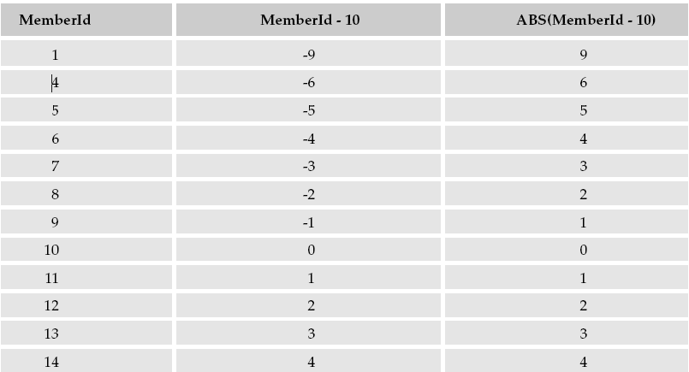

The POWER() Function
The POWER() function is an exponential function that raises a number by the power of a second number. The function takes two parameters. The first is the expression to be raised to a power, and the second is the power to which it is raised.
POWER(expression, power_raise_to)

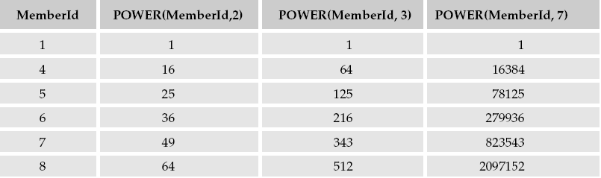
The SQRT() Function

The SQRT() function finds the square root of an expression, the opposite of what the POWER() function does. It takes just one parameter, the expression that you want to find the square root of, as shown in the basic syntax:
SQRT(expression_to_square_root)

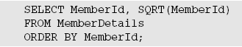

The RAND() Function

The RAND() function, which is short for random, generates a fractional random number between 0 and 1.

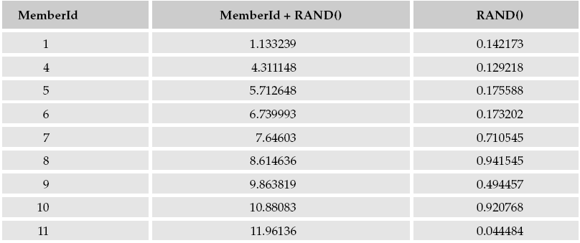

The CEILING() Function

The CEILING() function removes all the numbers after the decimal point and rounds up to the next highest integer. For example, 3.35 would be rounded up to 4, 5.99 rounded up to 6, and -3.35 rounded up to -3.

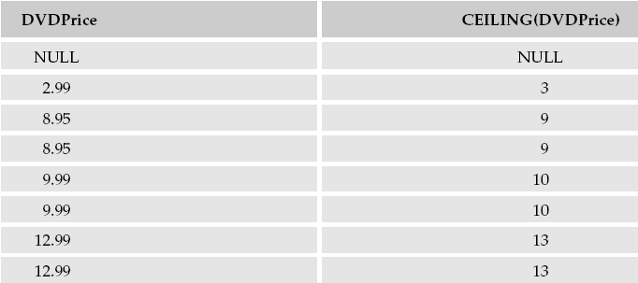

The FLOOR() Function
The FLOOR() function works in the opposite way as CEILING() in that it rounds down to the next lowest integer value. For example, 3.35 would be rounded down to 3, 5.99 rounded down to 5, and -3.35 rounded down to -4, as -4 is lower than -3
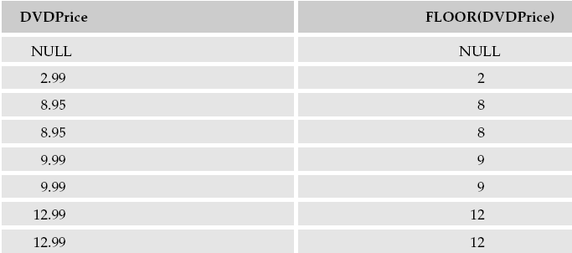
The ROUND() Function

The last of the rounding functions rounds in a more traditional way: to the nearest whole-number value. Rather than always rounding up like CEILING() or down like FLOOR(), the ROUND() function rounds based on the digits after the decimal point. If the digit after the decimal point is 4 or less, then it’s simply removed. If the digit after the decimal point is 5 or more, then the number is rounded up to the next highest whole number and the digit is removed

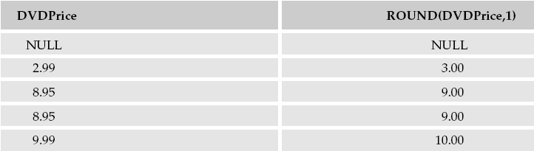

String Functions
The REVERSE() Function

The REVERSE() function reverses the order of the characters in a string. For example, ABC becomes CBA. It takes just one argument, the string to be reversed

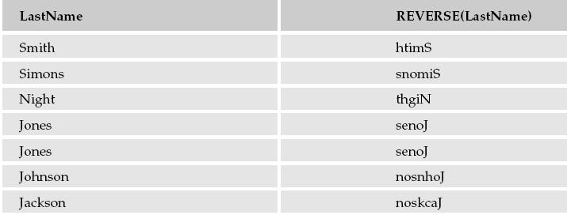
The LEN() Function

LEN() function used to find out how long a string is

